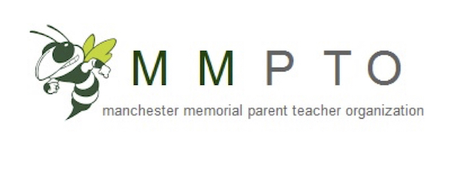
September 26th, 2018
PTO Meeting
8:45am
MMES Cafeteria

AGENDA

Welcome & Introductions

Principal Update from John Willis

Committee Introductions – Committee Leads
Treasurer
Enrichment
Directory
Sponsorships
Yearbook
Book Fair
Community Drives

Fundraising Events
Boosterthon Wrap Up
Eat Drink & Be Scary – 10/20
Volunteers Needed (set-up/clean-up, check-in/out, donations)
Original Art Works
Hit the Street For Little Feet
Ideas – Family Movie Night, Corn Hole Tournament, what else?

Upcoming Events
Scholastic Book Fair – week of 10/15
Eat Drink & Be Scary – 10/20
Wing Masters – 10/25 for entire school & 11/9 for 5th grade
Plimouth Plantation – 11/13

Volunteer Opportunities
Box Tops
School Spirit-wear
Annual Appeal
Family Fun-raising

